Kinematic model computation

Robot frame and parameter table (as defined currently):

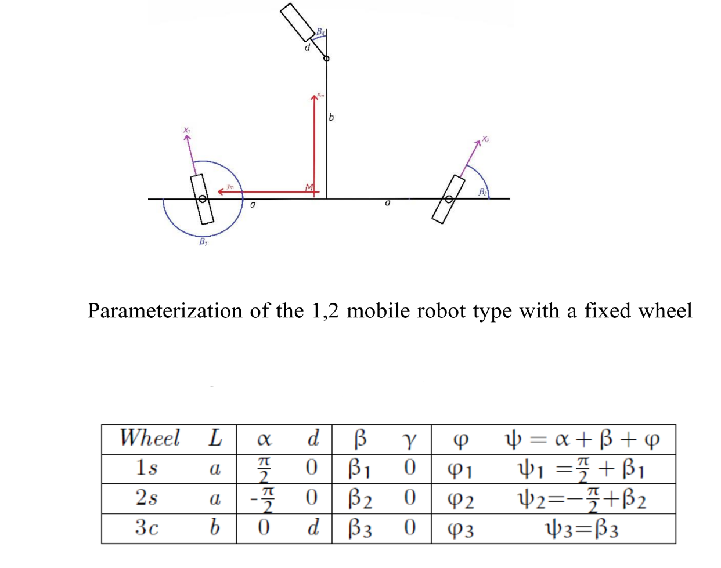

Configuration vector:

q = [x y θ β1 β2 β3 φ1 φ2 φ3]

We define some equivalences to have everything in terms of β:

sin(ψ1) = sin( β1 + π/2 ) = cos( β1 )

sin(ψ2) = sin( β2 - π/2 ) = -cos( β2 )

cos(ψ1) = cos(β1 + π/2 ) = -sin( β1 )

cos(ψ2) = cos( β2 - π/2 ) = sin( β2 )

Now we define J1, J2, C1 and C2:

From we obtain $C_{1}^{*}$:

$$C_{1}^{*}= \left[\begin{matrix}-\cos{β_{1}} & -\sin{β_{1}} & a . \cos{β_{1}} \\ \cos{β_{2}} & \sin{β_{2}} & a . \cos{β_{2}}\end{matrix}\right]$$

Now we turn $C_{1}^{*}$ into an upper triangular matrix (reduced row echelon form):

$$C_{1}^{*}= \left[\begin{matrix}1 & 0 & \frac{-a . \sin{(β_{1}+β_{2})}}{\sin{(β_{2}-β_{1})}} \\ 0 & 1 & \frac{2a .\cos{b_{1}}cosβ_{2} }{\sin{(β_{2}-β_{1})}}\end{matrix}\right]$$

And now we get a base of the kernel of $C_{1}^{*}$ to obtain $Σ$:

$$\begin{matrix}v_{1}- \frac{a . \sin\left(β_{1}+β_{2}\right)}{\sin\left(β_{2}-β_{1}\right)} v_{3}=0 ⟶v_{1}= \frac{a . \sin\left(β_{1}+β_{2}\right)}{\sin\left(β_{2}-β_{1}\right)} v_{3} \\ v_{2}+ \frac{2a .\cos{b_{1}}cosβ_{2} }{\sin\left(β_{2}-β_{1}\right)}v_{3}=0 ⟶v_{2}= -\frac{2a .\cos{b_{1}}cosβ_{2} }{\sin\left(β_{2}-β_{1}\right)}v_{3}\end{matrix}$$

Then $Σ$ is:

$$Σ= λ\left[\begin{matrix}\frac{a . \sin\left(β_{1}+β_{2}\right)}{\sin\left(β_{2}-β_{1}\right)} \\ -\frac{2a .\cos{b_{1}}cosβ_{2} }{\sin\left(β_{2}-β_{1}\right)} \\ 1\end{matrix}\right]$$

We can multiply everything by $\sin{(β_{2}-β_{1})}$ to finally obtain:

$$Σ= \left[\begin{matrix}a . \sin\left(β_{1}+β_{2}\right) \\ -2a .\cos{b_{1}}cosβ_{2} \\ \sin{(β_{2}-β_{1})}\end{matrix}\right]$$

Now, before obtaining S(q) we need to calculate the E and D matrices:

$$E= -J_{2}^{-1}. J_{1}= \frac{-1}{r}\left[\begin{matrix}-\sin{β_{1}} & \cos{β_{1}} & a . \sin{β_{1}} \\ \sin{β_{2}} & -\cos{β_{2}} & a . \sin{β_{2}} \\ \cos{β_{3}} & \sin{β_{3}} & b . \sin{β_{3}}\end{matrix}\right]$$

$$D= -C_{2c}^{-1}. C_{1c}= \frac{-1}{d} \left[\begin{matrix}-\sin{β_{3}} & \cos{β_{3}} & d+b . \cos{β_{3}}\end{matrix}\right]$$

Finally:

$S\left(q\right)= \left[\begin{aligned}\begin{matrix}Ω\left(θ\right) . Σ & 0 \\ 0 & I \\ D . Σ & 0\end{matrix} \\ \begin{matrix}E . Σ & 0\end{matrix}\end{aligned}\right]$, with $Ω\left(θ\right)=\left[\begin{matrix}\cos{θ} & -\sin{θ} & 0 \\ \sin{θ} & \cos{θ} & 0 \\ 0 & 0 & 1\end{matrix}\right]$

$$S\left(q\right)= \left[\begin{matrix}a .\cos{θ}\sin{(β_{1}+ β_{2})}+2a .\sin{θ}\cos{β_{1}}\cos{β_{2}} & 0 & 0 \\ a .\sin{θ}\sin{(β_{1}+ β_{2})}-2a .\cos{θ}\cos{β_{1}}\cos{β_{2}} & 0 & 0 \\ \sin{(β_{2}-β_{1})} & 0 & 0 \\ 0 & 1 & 0 \\ 0 & 0 & 1 \\ \frac{a}{d}\sin\left(β_{1}+β_{2}\right)\sin{β_{3}}+ \frac{2a}{d}\cos{β_{1}}\cos{β_{2}}\cos{β_{3}}-\sin\left(β_{2}-β_{1}\right)-\frac{b}{d}\sin\left(β_{2}-β_{1}\right)\cos{β_{3}} & 0 & 0 \\ \frac{2a}{r}\cos{β_{2}} & 0 & 0 \\ \frac{-2a}{r}\cos{β_{1}} & 0 & 0 \\ \frac{1}{r}(2a .\cos{β_{1}}\cos{β_{2}}\sin{β_{3}}-a.\cos{β_{3}}\sin\left(β_{1}+β_{2}\right)-b.\sin{β_{3}}sin⁡(β_{2}-β_{1}) & 0 & 0\end{matrix}\right]$$

The S(q) presented in the previous’ year report is as follows:

The main difference lies in the first 3 rows, where an additional reduction appears to be made but there is no apparent way to obtain these values.